OPERATING SYSTEM

1. On your Windows laptop or PC, open 'System Information' and take a screenshot showing your OS version, processor, and RAM details.

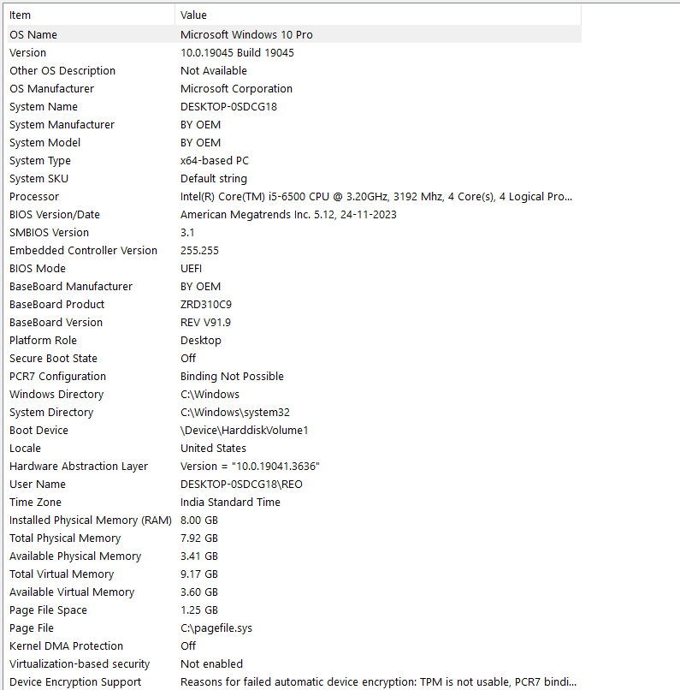

2. Download any official Linux distribution ISO (like Ubuntu or Fedora), and use Rufus or BalenaEtcher to create a bootable USB drive for installation.<br><br><em><strong>Hint:</strong> If you don't have a spare USB, use a virtual machine tool like VirtualBox to mount the ISO and start the installation process virtually.</em>
STEPS :
- Open the official Ubuntu website and download the Desktop ISO file.
- Visit the official website and download Rufus for Windows.
3. Insert a USB drive (8 GB or larger recommended).
Open Rufus and select your USB drive.
Select the downloaded Ubuntu ISO file.
Click Start and wait for the process to finish.

3.On a macOS device (or using a macOS virtual machine), open 'System Preferences' and change the desktop wallpaper, then adjust the system language to Hindi orGujarati.<br><br><em><strong>Hint:</strong> Find 'Language & Region' in System Preferences to add or change languages.</em>.
Steps 1 : Change the desktop wallpaper
Open your Mac and click the Apple menu ().
Open System Settings (or System Preferences on older macOS versions).
Click Wallpaper.
Select any wallpaper you like.
Confirm that your desktop background has changed.
Steps 2: Change the system language
Open System Settings.
Select General → Language & Region.
Click the + (Add Language) button under Preferred Languages.
Search for Hindi or Gujarati.
Select your chosen language and click Add.
If prompted, choose to use it as the primary language.
Restart or log out if macOS asks you to do so.
Steps 3: verify your assignment
Desktop wallpaper has changed.
Hindi or Gujarati has been added as a preferred language.
The system language has been changed if the assignment requires it.
Take screenshots of the changed wallpaper and the Language & Region settings as proof.
4. Install a fresh copy of Ubuntu Linux (real or virtual machine) and create a new user account named 'gamer'. After installation, enable automatic login for this user and take a screenshot of the login screen showing the username.

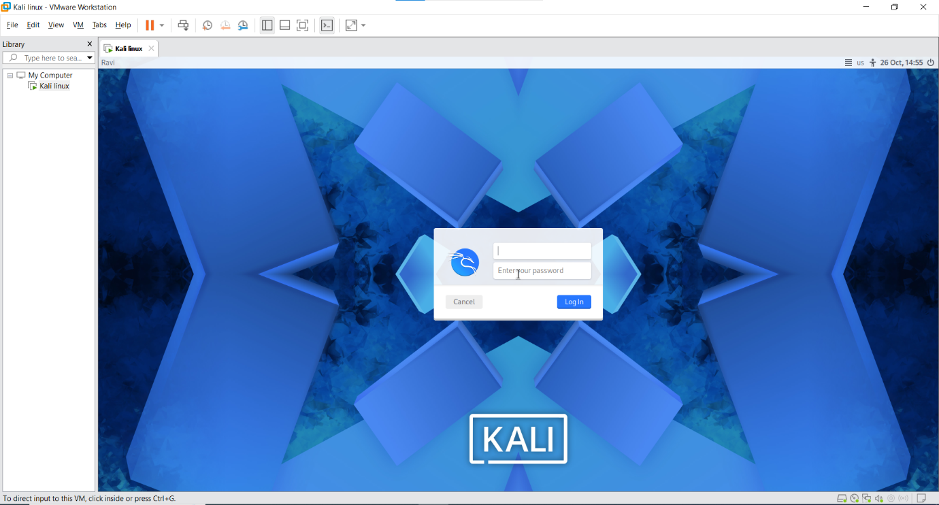
5. Use ChatGPT to generate a step-by-step guide for installing Windows 10 on a laptop, including partitioning tips and post-installation settings for privacy and updates. Follow the guide and note any steps that were unclear or missing.

Step:
1. Requirements before installation
Before installing Windows 10, prepare the following:
- Laptop with a compatible processor.
- Minimum 4 GB RAM recommended.
- At least 64 GB storage.
- 8 GB or larger USB flash drive.
- Windows 10 ISO file downloaded from Microsoft's official website.
- Rufus tool to create a bootable USB.
- Backup of important files.

2. Download Windows 10
- Open a web browser.
- Visit the official Microsoft Windows 10 download page: https://www.microsoft.com/software-download/windows10
- Download the Windows 10 installation media or ISO.
- Save the downloaded file.

3. Create a bootable USB drive
- Insert an 8 GB or larger USB drive.
- Download and open Rufus.
- Select your USB drive.
- Select the Windows 10 ISO file.
- Choose the correct partition scheme:
  - GPT for UEFI systems.
  - MBR for older BIOS systems.
- Click Start.
- Wait until the bootable USB is ready.

4. Boot the laptop using USB
- Connect the bootable USB to your laptop.
- Restart the laptop.
- Press the boot menu key (F12, F9, Esc, or F2, depending on the laptop).
- Select the USB drive.
- Press Enter.
- Windows Setup will appear.
5. Install Windows 10
Select your language, time, and keyboard layout.
- Click Next.
- Click Install Now.
- Enter your Windows product key or select the option to enter it later.
- Accept the license terms.
- Select Custom: Install Windows only (Advanced).
- Choose the target partition.
- Click Next to begin installation.
- Wait for Windows to copy files and restart.
6.Partitioning tips
Partitioning divides your hard drive or SSD into separate sections.
Example partition plan for a 256 GB SSD:
Partition | Suggested size | Purpose
C: Drive | 150 GB | Windows and applications
D: Drive | Remaining space | Personal files

7. Complete Windows first-time setup
- Select your country or region.
- Choose your keyboard layout.
- Connect to Wi-Fi.
- Create a user account.
- Set a strong password.
- Configure privacy settings.
- Complete the setup and reach the Windows desktop.

8. Configure privacy settings
After installation:
- Open Settings.
- Select Privacy.
- Review the following settings:
  - Turn off unnecessary location access.
  - Disable unnecessary diagnostic data sharing where available.
  - Review camera and microphone permissions.
  - Disable unnecessary advertising personalization.
  - Review app permissions.

9. Install Windows updates
- Open Settings.
- Click Update & Security.
- Select Windows Update.
- Click Check for updates.
- Download and install available updates.
- Restart the laptop if required

10. Install drivers and applications
- Install graphics drivers.
- Install audio drivers.
- Install Wi-Fi and Bluetooth drivers.
- Install antivirus/security software.
- Install required applications such as Chrome, MS Office, and VLC.

